AUTUMN MELODIES
“Autumn Spider”
(Song Caminos Rancheros/Fall Equinox 1975/Gioia).
The Great Blafigria, Vol. II E III
Once there was a spider
Just finishing her web
But autumn came
With red and yellow leaves, and the wind
That blew her web away.
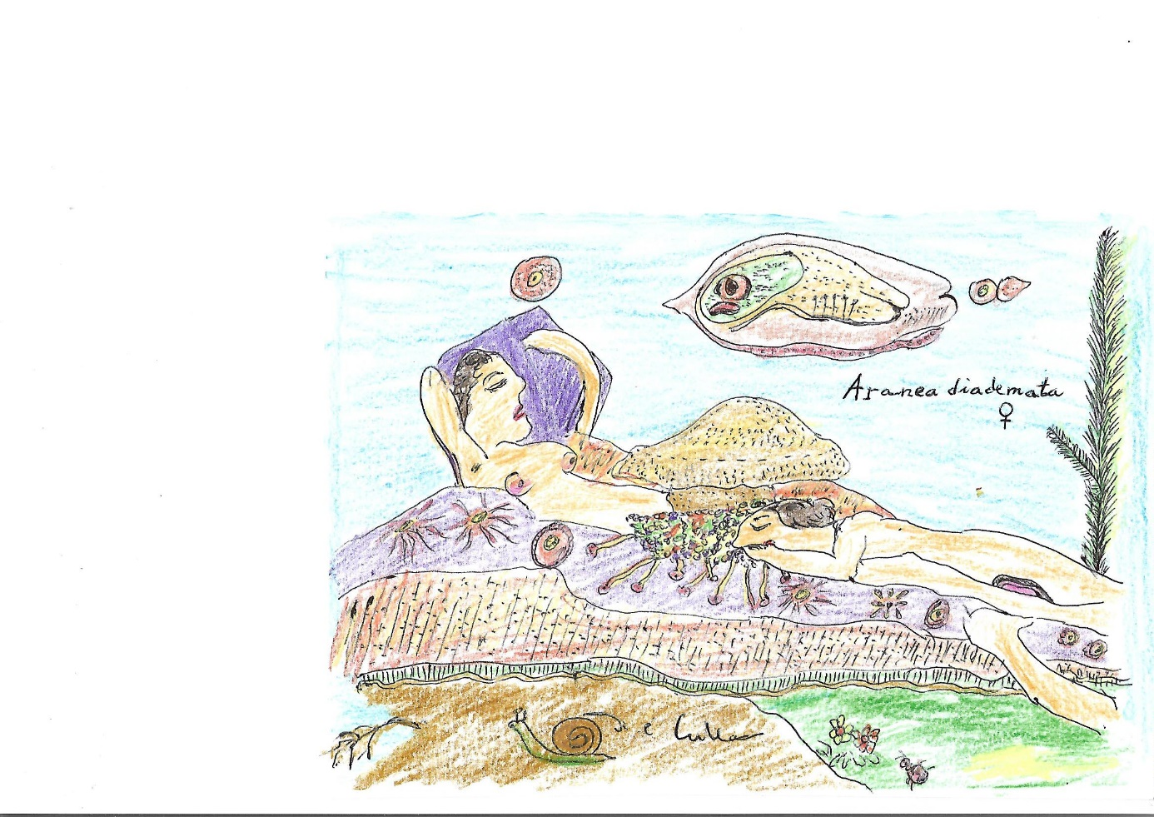

She fell on a white bench
Part of this magic park
Where I’ve seen many lovers’ shadows
Amd I sang it all to my self.
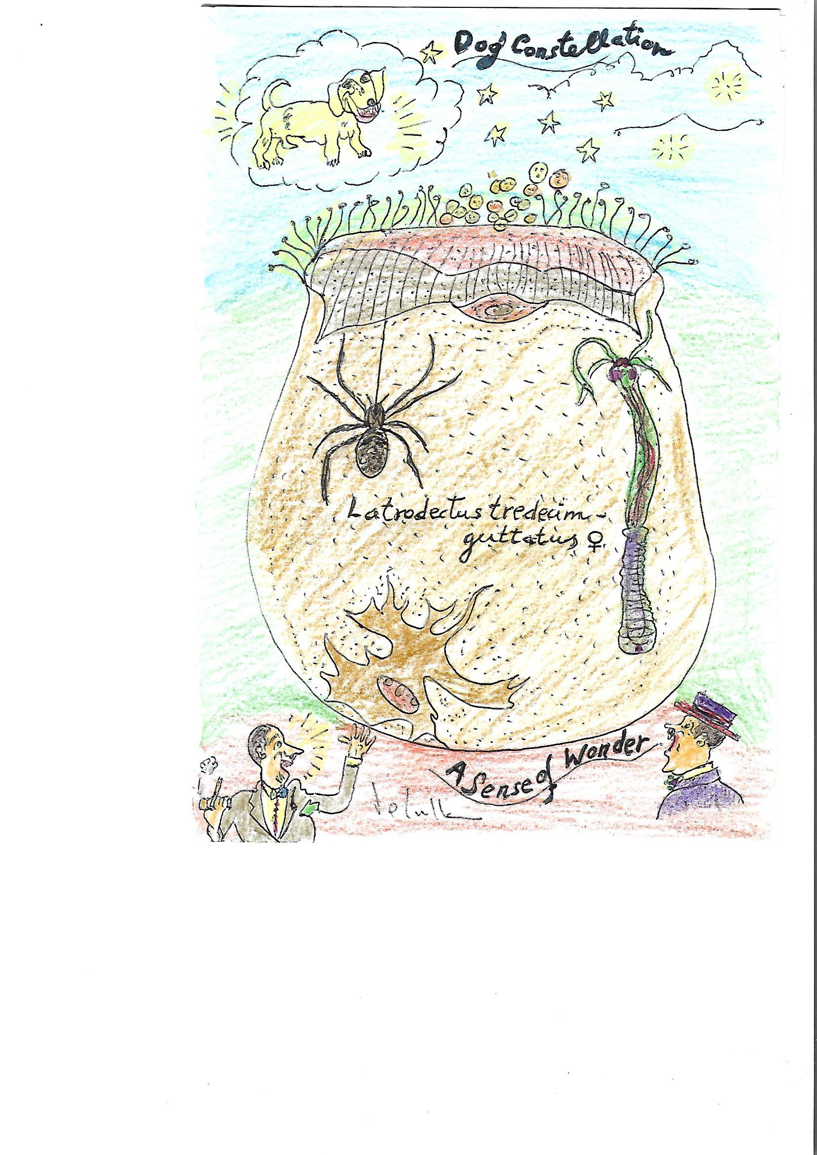
This park had many words
Sprouting all around
So I spent a lot of time
Just looking at the ground.

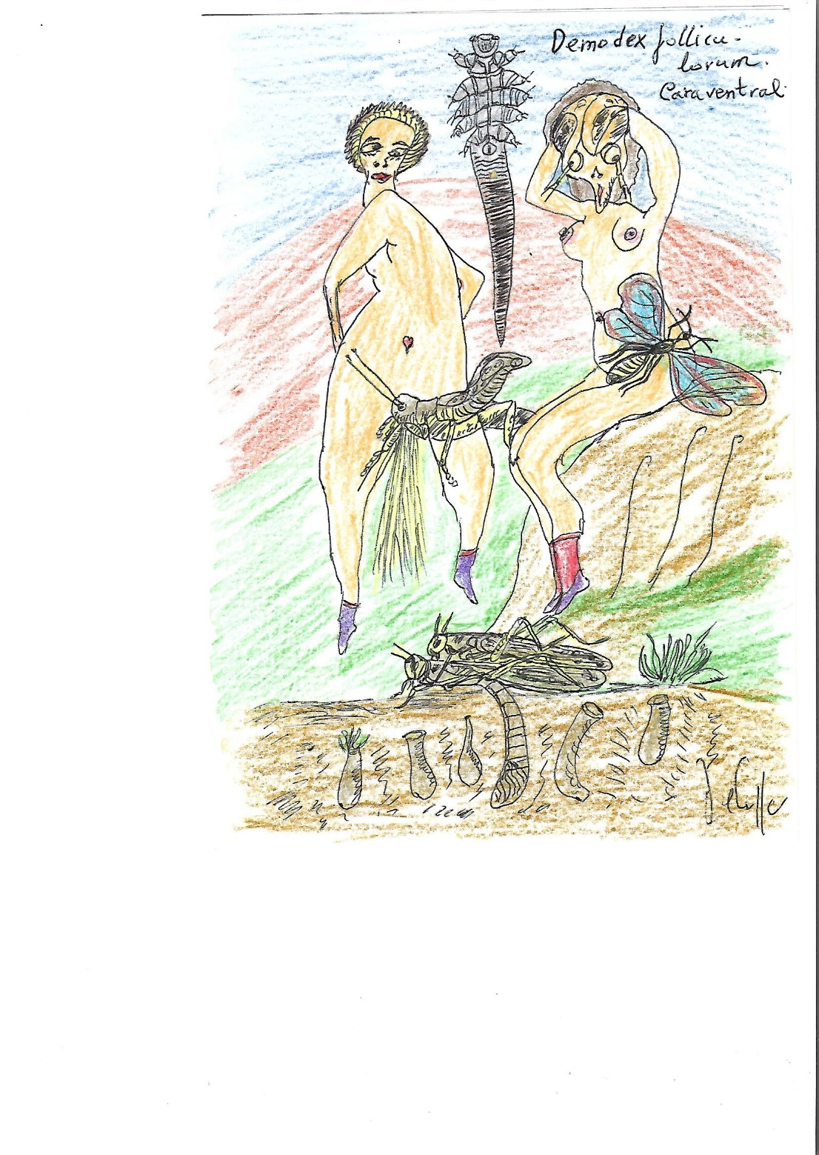
The ground became so warm and soft
That I just had to lay dowm,
A world of words lying beside me
And the spider, who had found under my arms
A windproof corner
Began again to weave her life.

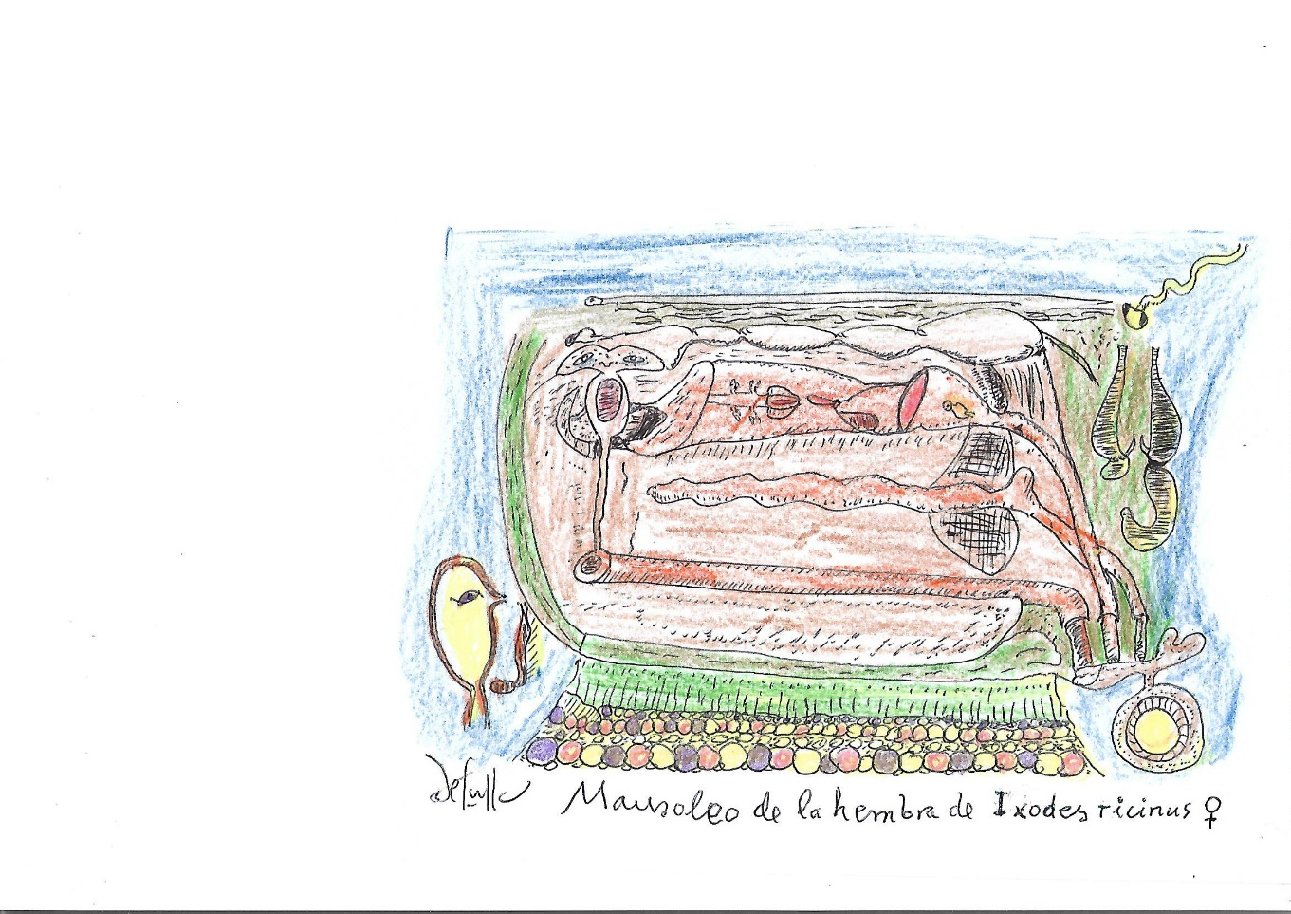
I have been lying on the ground since then
Eating the words beside me.
Today I shall eat all the legtters
That spell simplicity.

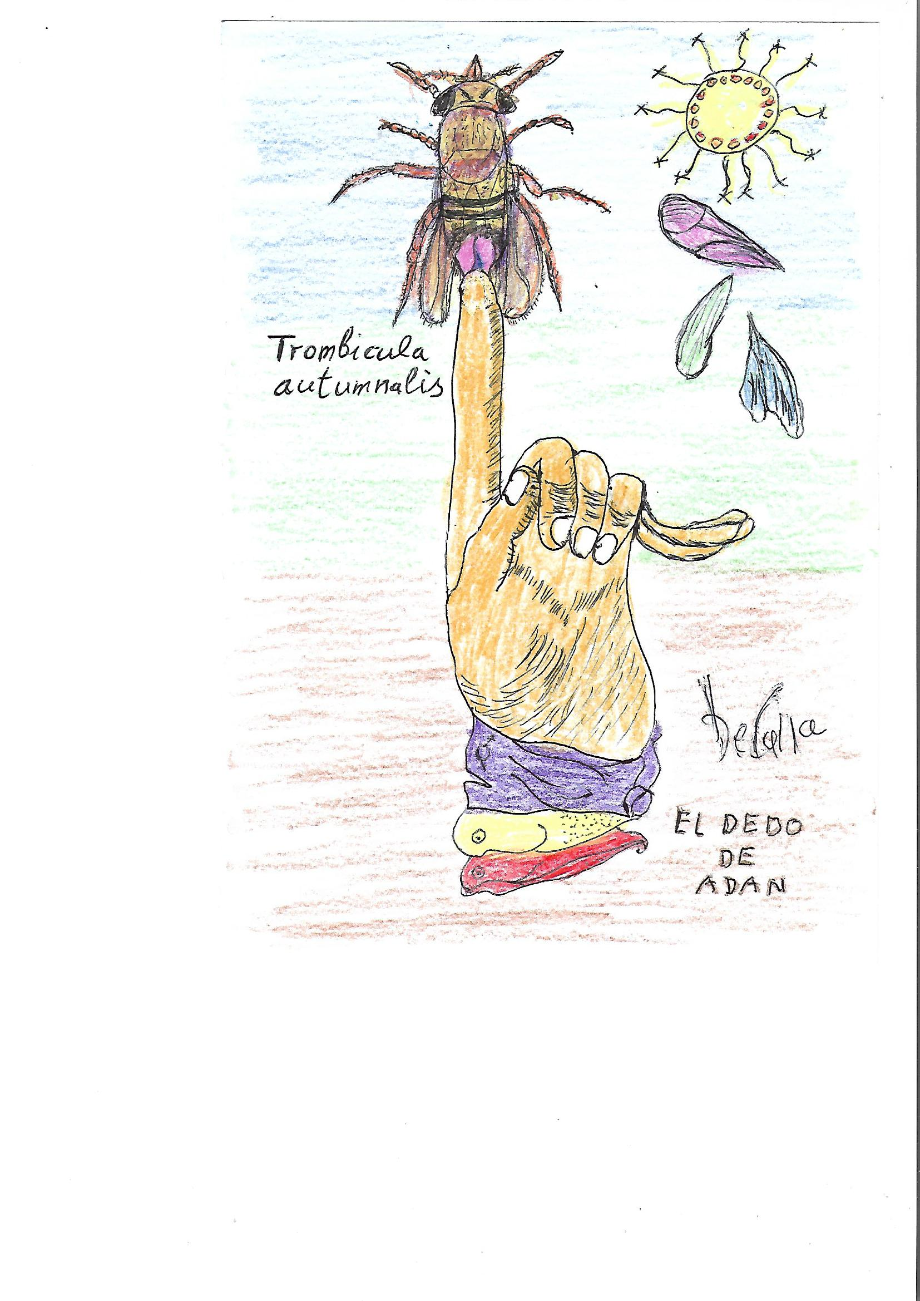

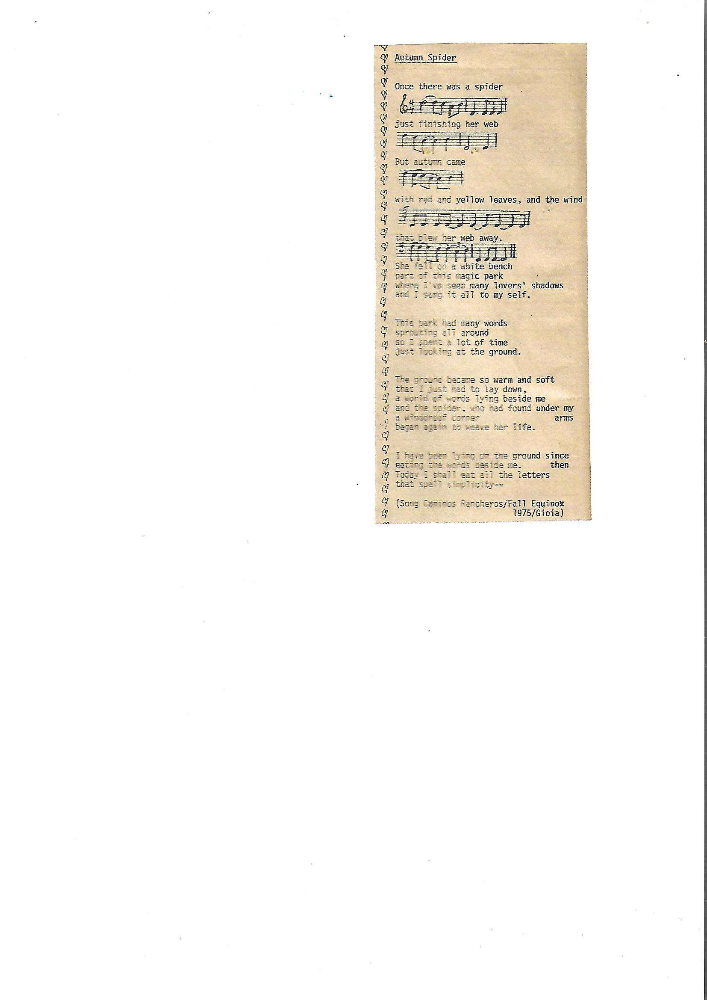
-Daniel de Cullá

