Three Arts
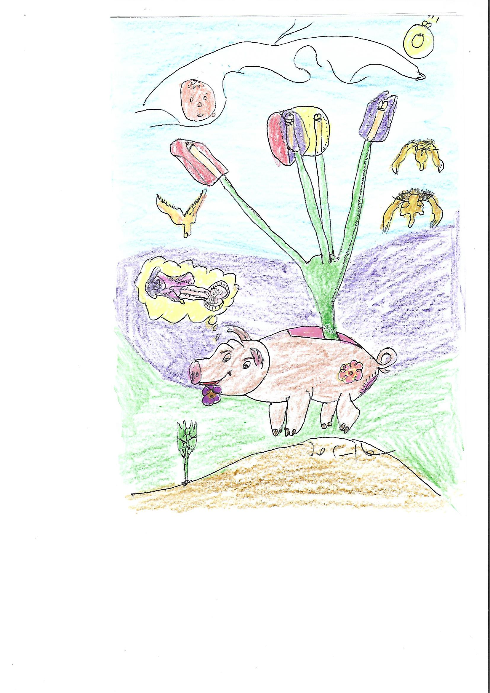
TULIPS
Daniel de Culla
gallotricolor@yahoo.com
Hand Drawing with pencil and colours.
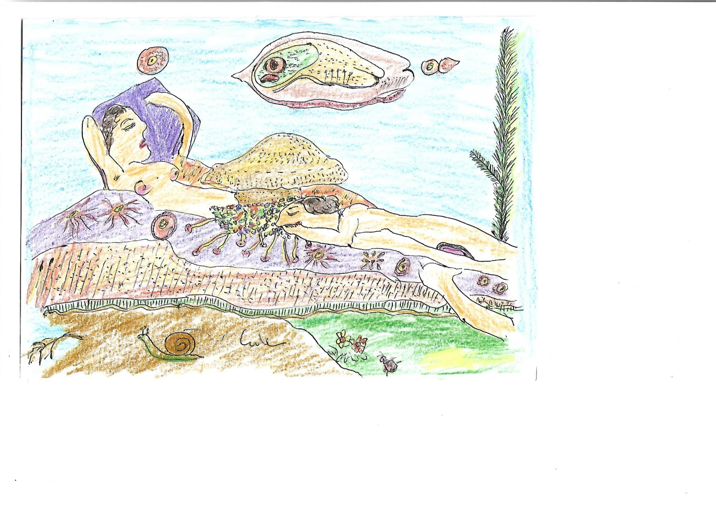
RASCAL WOMEN
Daniel de Culla
gallotricolor@yahoo.com
Hand Drawing with pencil and colours.
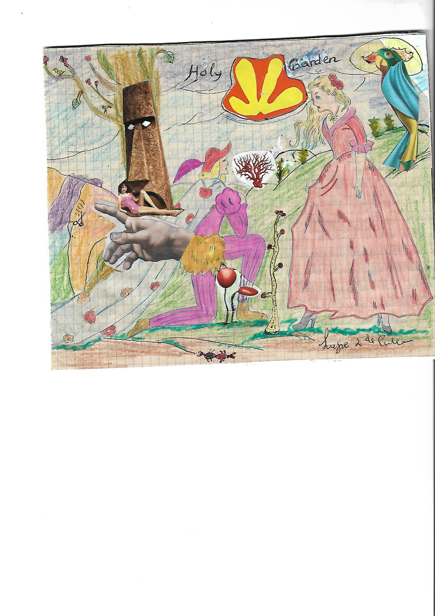
HOLY GARDEN, Daniel de Culla
gallotricolor@yahoo.com. Hand Drawing with pencil and colours.

