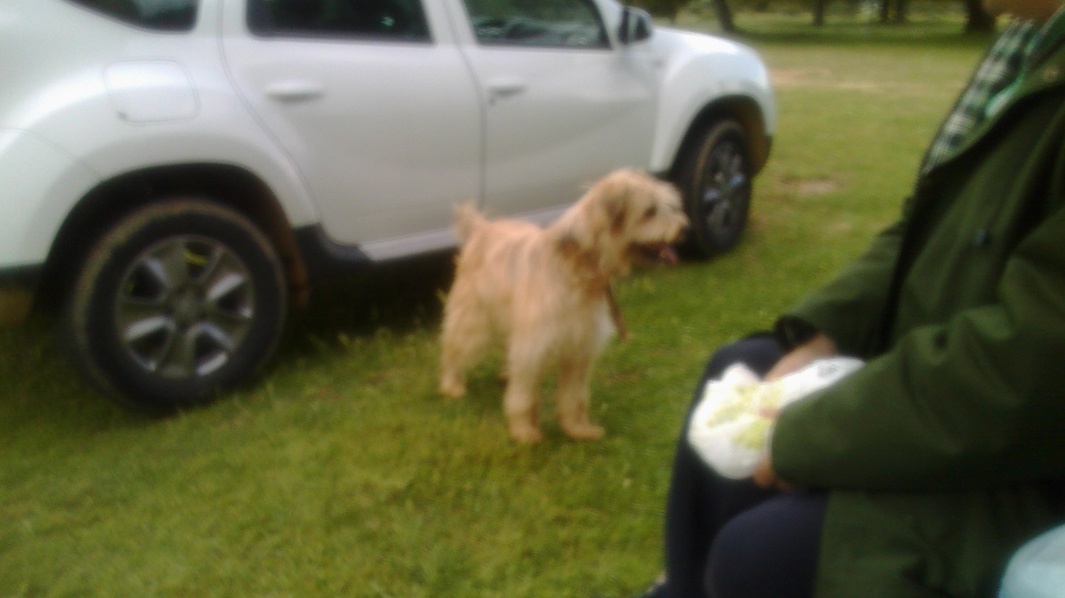
(De Culla’s Pic)
TIME TRAVEL
Time Travel
As the HG Well’s The Time Machine
With philosophy and fiction
Outside the sense & perception:
An arbitrary travel in spacetime
Connected with quantum mechanics
And wormholes.
Einstein-Rosen bridges ¡
Surely celebrating
The feline sense of traffic.

-Daniel de Culla

