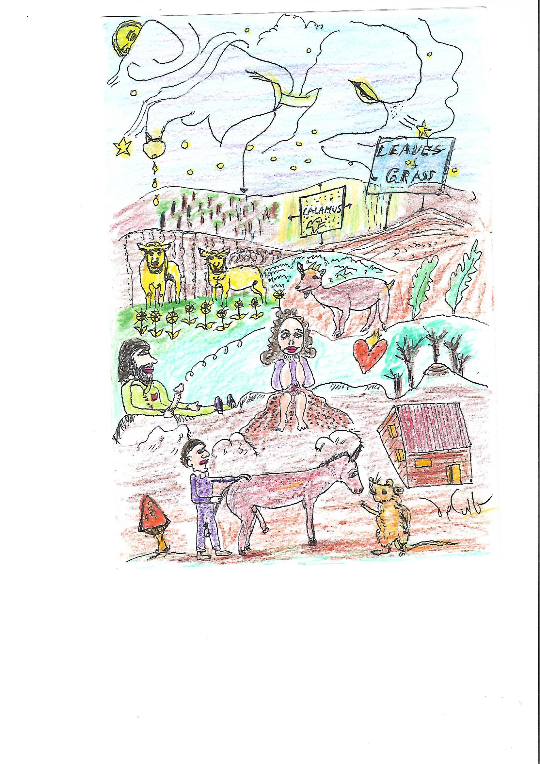

WALT WHITMAN PURSUING BEAUTY
( In his 200 Aniversary )
His Biosphere, his Biorealm, his Bioprovince
His Bioregion, his Biolocale
Beat plunged humming “Leaves of Grass”
Throught drunken twisted paths
Stumbling pleasures and thinking about
The quality of being different
Transparent, unthinkable
Just talking from experience
Tracing the tread of our heads
Into a web and so mysterious and clear.
Despite the Presbyterian pastor’ words
Ralph Smith
Saying with envy and burr:
- Walter is a Freeroamer of Love
That has converted the Locust Grove School
In a School of Sodoma
Or the John Peter Lesley’s, geologist:
-Walter is a “pretencious gil”
And his Leaves of Grass
Are “profane and obscene trash”
Walter and his Leaves of Grass
Still are a promise and a delight.
We’ve been thinking about his offer
And their answer is a strong tentative yes.
I love it:
His new possible consciousness of the Earth
Filled with demons – making scenes
Of Love and Freedom
Wastings what he has given to You and me:
Leaves of Grass
And its natural science: that the Earth
Is the center of the attention
Not another’s manipulation on it.
It is a lovely pamphlet of possible Life.
O honey
Walter, You’re an acorus calamus
I love You.

-Daniel de Culla

