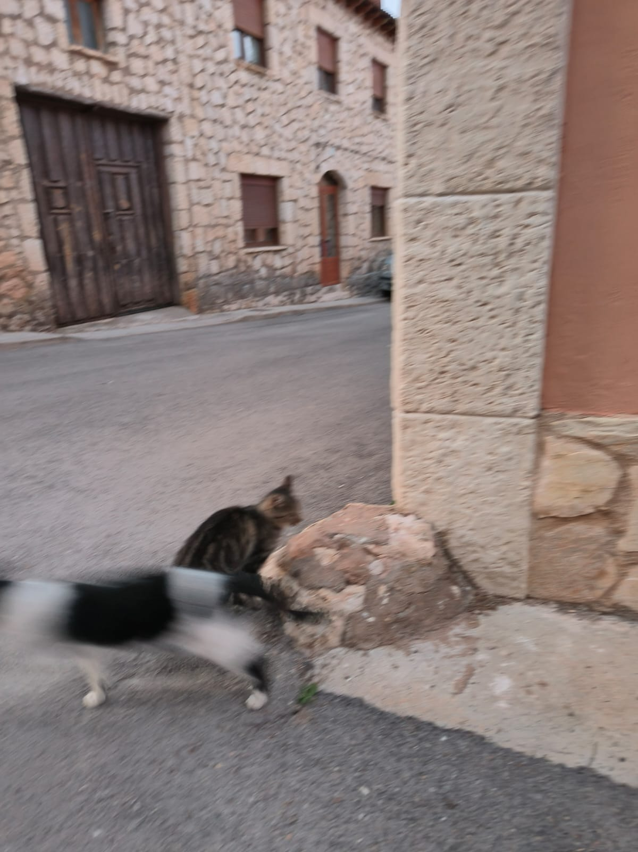
Isabel G. der Diego’ photo
IN MIAMI AS IN BERLIN
In Miami, as in Berlin, people dress up
To attend charity events
Where everyone admires themselves
For the elegance of their suits
And how well these clothes look on them
Taken out of the closet to do charity.
What hypocrisy, oh my god ¡ seeing me at the “Diamond Ball”
Held at the Loews Miami Beach Hotel
At the Annual “Wild About Kids” Gala:
A Night in Motown - Boys & Girls Clubs of Miami-Dade
At the Loews Coral Gables Hotel
Or at the Choose Your Sound Halloween Ball
On Jungle Island
Or with the South Florida Youth Symphony
At Miami Shores Country Club
Making an Escape to Neverland
In benefit, after a great dinner
From the Nicklaus Children's Hospital Foundation
Or from South Florida Music Students
Or at the Rendezvous at the Paris Opéra
– The Pink Diamond Affair Gala
At the Ritz Carlton Coconut Grove
Or at Campfires to Cocktails
With the Girl Scouts of Tropical Florida at Camp Mahachee
Or Make-A-Wish Southern Florida
At the InterContinental Miami
And other luxurious gatherings and festivals
Forgotten children, men, women and mothers
Who are massacred, tanked or shot
In Palestine right now, and every day
As in many other parts of the Globe
As before in Berlin that terrible beast
That made a fire of bones and skulls
Not Jews, because they were gassed
But yes of agnostics, atheists and anarchists
Vilely persecuted and murdered for their ideas
Having a great time in that luxurious brothel
Berlin's Salon Kitty, spy center
From Nazi German Intelligence
Where the criminal and murderous Führer
Addressed, in these terms, foreign dignitaries
German businessmen and officers
After a beautiful German girl gives him a handjob
First class prostitute:
-Drink and toast with these skulls
It may be that one day not too far away
I drink from yours.
What happiness here far from wars
Tripping really well, and with a navel full of crumbs!
This is life, the rest is death.
Now I enjoy Make-A-Wish Southern Florida
At the InterContinental Miami
With the 18th Annual Claws for Kids Fundraising Luncheon.
I'm already trying to get laid at the Biscayne Bay Yacht Club
Lefting the door half open
From where I see the Coral Gables Museum.
My head is spinning like in a Caribbean film session
At the Pérez Art Museum Miami
Feeling like a warrior performer
At Thomson Plaza for the Arts.
I want to go to war to liberate Peace
On a Moonlight Kayak Tour at Deering Estate
And not like others who are going to eat chickpeas or beans.
I don't know if I woke up
But I open my eyes and I see myself naked
In front of the Phillip and Patricia Frost Museum of Science.
Bombings, missiles, tanks and explosions
The destruction, the deaths, the ruin of the human being
These look like the Frost Symphony Orchestra to me
And the Vampires 101 Pop-up Exhibition together
Making my whole body shake.
I open one of the three eyes; I don't know which one.
I’m looking like Polyphemus
A bearded giant with only one eye
In the middle of the forehead
And the pointy ears farting (the ears)
Like someone who sings a song in his sling.
I look happy because I am far from the Wars.
Lords of wars, murderous criminals
Death is your mother-in-law¡
-Daniel de Culla

