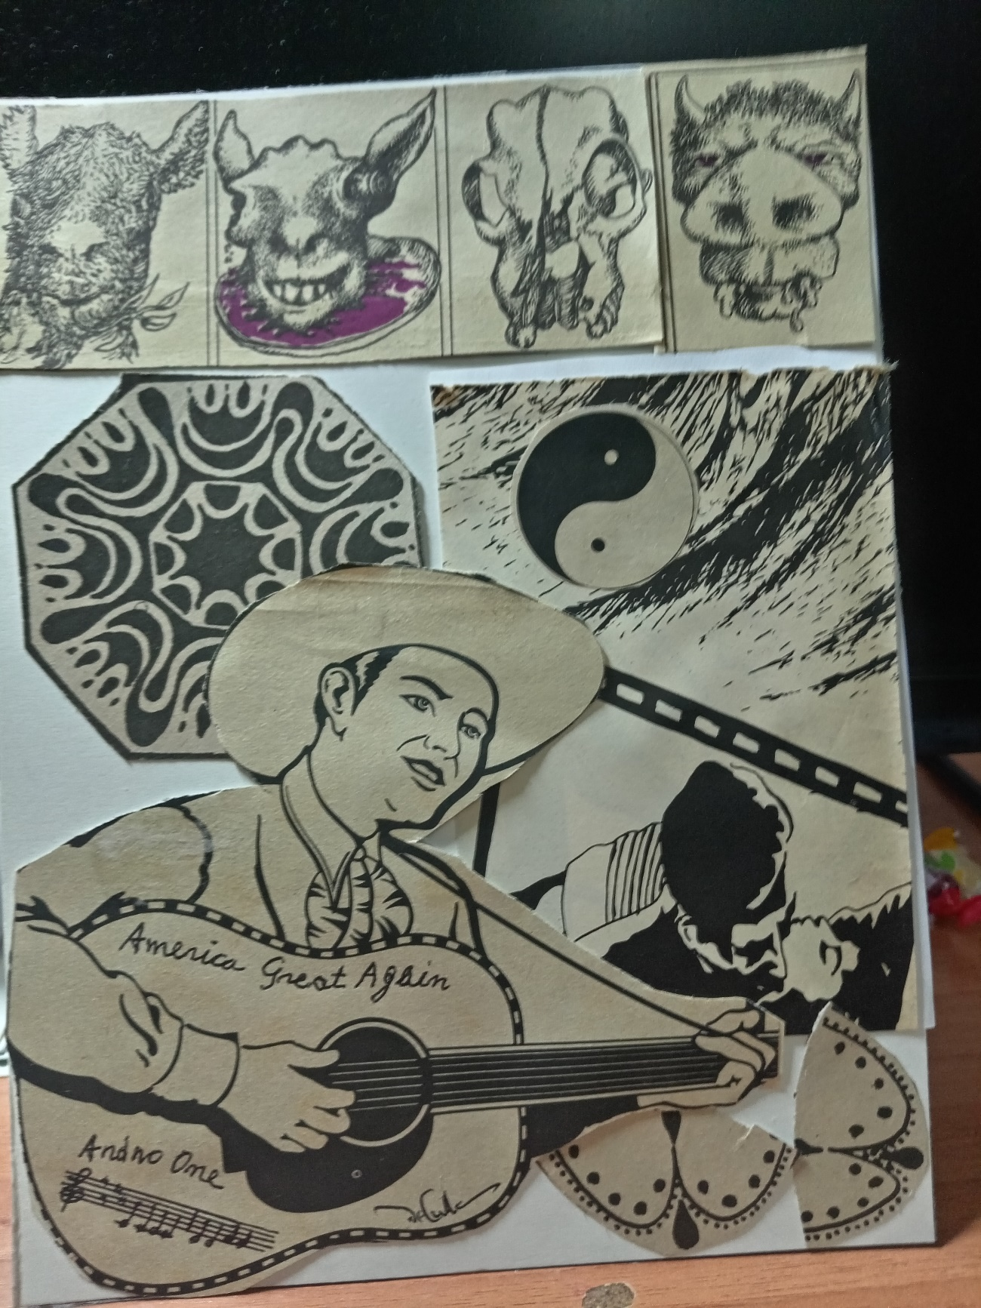
O ABOUT THE BIG HEE-HAW AGAIN
All the nations
They are stalking a big Donkey
Who was a demon
On a certain cold and rainy afternoon of votes
He became a demigod of the World
Thanks to his great Brays
Which were the cause of his triumph
So great and stupendous.
The Republicans tell us
What a Hee-Haw given in time is worth
While the terrified Democrats
Instantly think of abandoning their camp
Believing wholeheartedly
That such a rumor
Can only be from some frightful animal
Which, back then
Kicked them in the sky of their ass
Putting them to flight
Like all the undocumented
Ringed for Mexico or Guantanamo
Who sacrifice dogs and cats
And eat them before or after raping them.
Democracy is in defeat and flight
Thanks to that long-awaited triumph
By crypto-fascists, religious people, gurus
And other psychopathic elements
Who rely on that tremendous Bray
Given in time
By this orange Donkey
Carrot-colored
Named Hee-Haw
Who relies only on his dick
Where his brain is
As many newspaper authors
And newscasts refer
Adding that because this Donkey is so daring
All the nations of the Globe
Will sacrifice themselves to him like Donkeys
For his warlike clamor
And for the loud noise he makes when Braying
Which makes
Even the bells of St. Peter ring in Rome
Everyone is afraid
That he will press with his dick
In his ravings and clamorous Braying
The button of the atomic or nuclear bomb
And leave us all
Naked and shitting mortality.
-Daniel de Culla

